**ASSIGNMENT-II**

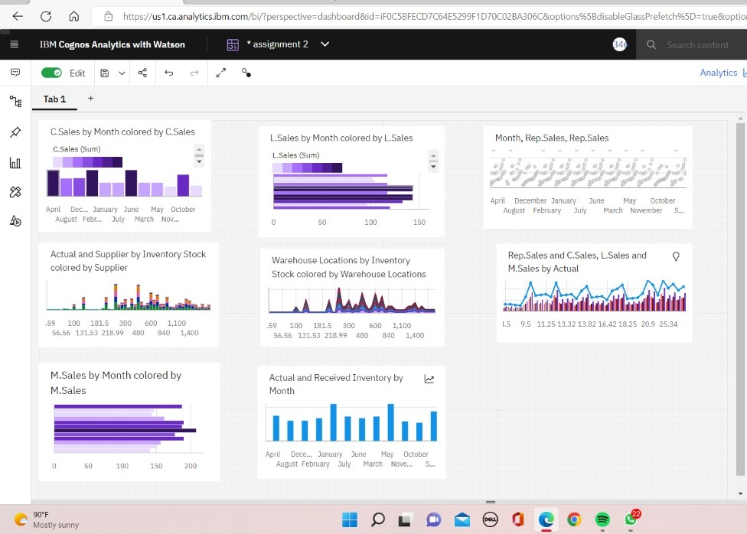

**LINK:**

<https://us1.ca.analytics.ibm.com/bi/?perspective=dashboard&pathRef=.my_folders%2Fassignment%2B2&action=view&mode=dashboard&subView=model0000018374934113_00000003>